**Урок 7. Лабиринт (Python, PyGame)**

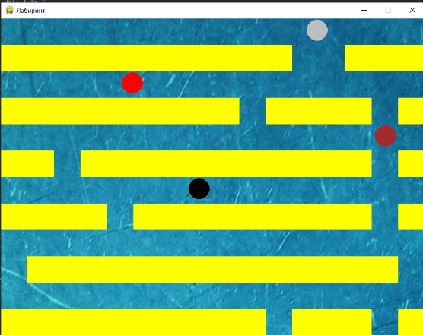

import pygame

from random import randrange

W = 800

H = 600

S = pygame.display.set_mode((W, H), 1, 32)

pygame.display.set_caption('Лабиринт')

clock = pygame.time.Clock()

blocks = []

for y in range(50, H, 100):

x1, x2 = randrange(0, W, 50), randrange(0, W, 50)

for x in range(0, W, 50):

if x == x1 or x == x2:

continue

b = pygame.Rect(x, y, 50, 50)

blocks.append(b)

ball = pygame.Rect(0, 0, 45, 45)

img = pygame.image.load('1.jpg').convert()

enemy1 = pygame.Rect(100, 100, 45, 45)

enemy2 = pygame.Rect(100, 200, 45, 45)

enemy3 = pygame.Rect(100, 300, 45, 45)

def exitGame():

for e in pygame.event.get():

if e.type == pygame.QUIT:

pygame.quit()

level1 = True

dx, dy = 0, 0

clock = pygame.time.Clock()

def checkColission(x, y):

hit = ball.collidelist(blocks)

print(hit)

if hit >= 0:

ball.x -= x

ball.y -= y

while level1:

exitGame()

S.blit(img, (0, 0))

for i in range(len(blocks)):

pygame.draw.rect(S, 'yellow', blocks[i])

pygame.draw.circle(S, 'gray', ball.center, 20)

pygame.draw.circle(S, 'red', enemy1.center, 20)

pygame.draw.circle(S, 'brown', enemy2.center, 20)

pygame.draw.circle(S, 'black', enemy3.center, 20)

keys = pygame.key.get_pressed()

if keys[pygame.K_LEFT] and ball.left > 0:

ball.x -= 5

checkColission(-5, 0)

if keys[pygame.K_RIGHT] and ball.right < W:

ball.x += 5

checkColission(5, 0)

if keys[pygame.K_UP] and ball.top > 0:

ball.y -= 5

checkColission(0, -5)

if keys[pygame.K_DOWN] and ball.bottom < W:

ball.y += 5

checkColission(0, 5)

enemy1.x += 2

enemy2.x -= 3

enemy3.x += 4

if enemy1.right > W:

enemy1.x = 0

if enemy2.right < 0:

enemy2.x = W

if enemy3.right > W:

enemy3.x = 0

if ball.colliderect(enemy1):

ball.topleft = (0, 0)

clock.tick(100)

pygame.display.update()